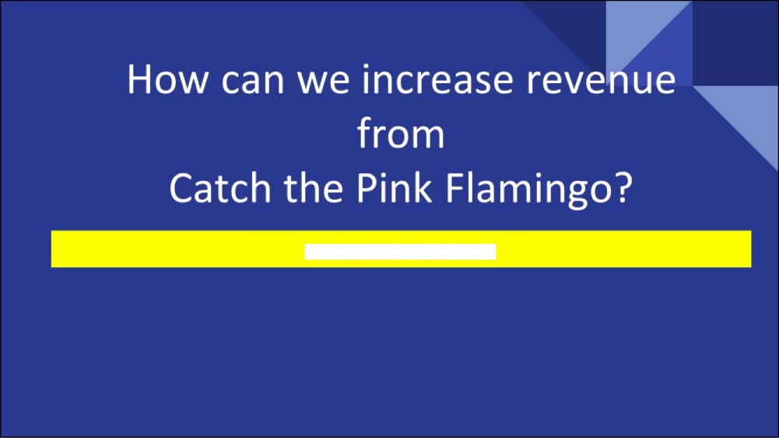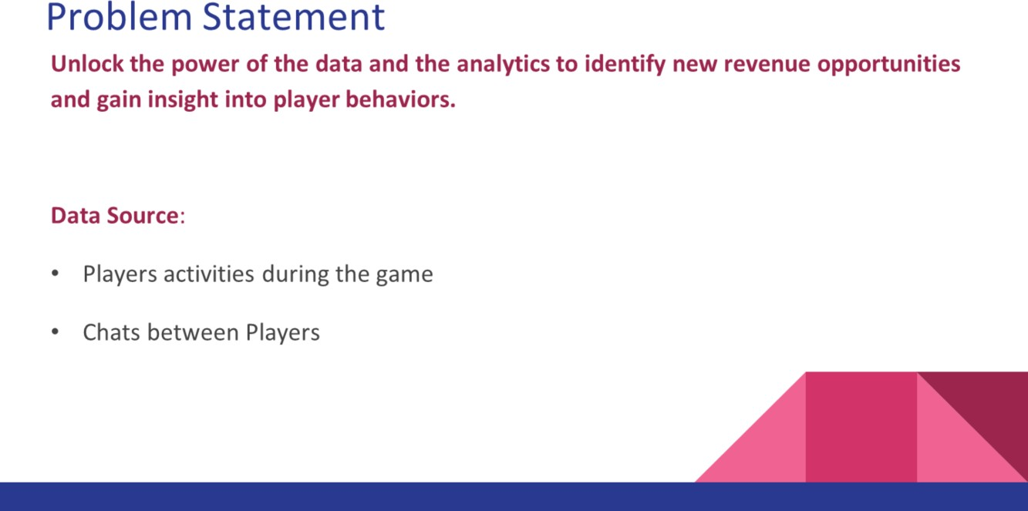

# Players activities during the game

This data help us to evaluate when and where the users clicks on the screen, when the user purchase an in-app item or clicks on a banner. Understanding this data help us to evaluate and design better game UX that convert more, target specific promotion to specific users and price strategy.

# Chats between players

This data is very useful, we can find the most influential players and what is the hottest topic. We can define more efficient marketing campaign strategies based on the insights we discovered from this data.

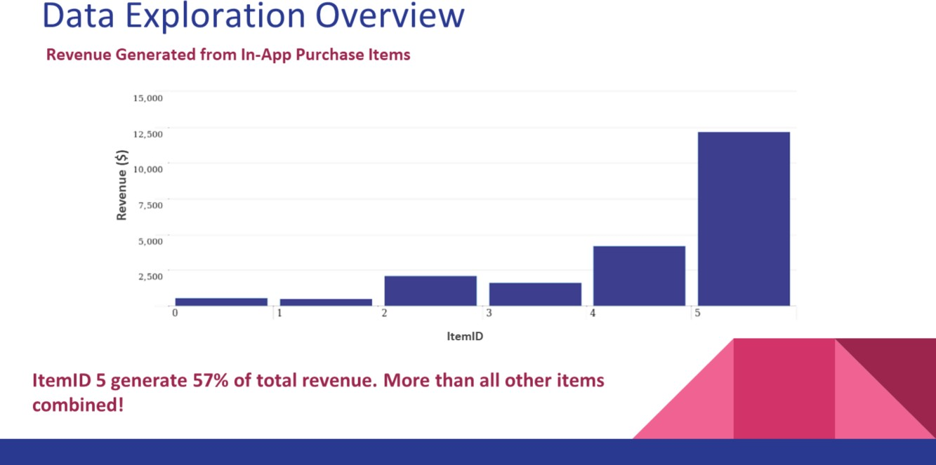

# ItemID 5 generate 57% of total revenue. More than all other items combined!

We could develop a marketing strategy that promote sales of itemID 5.

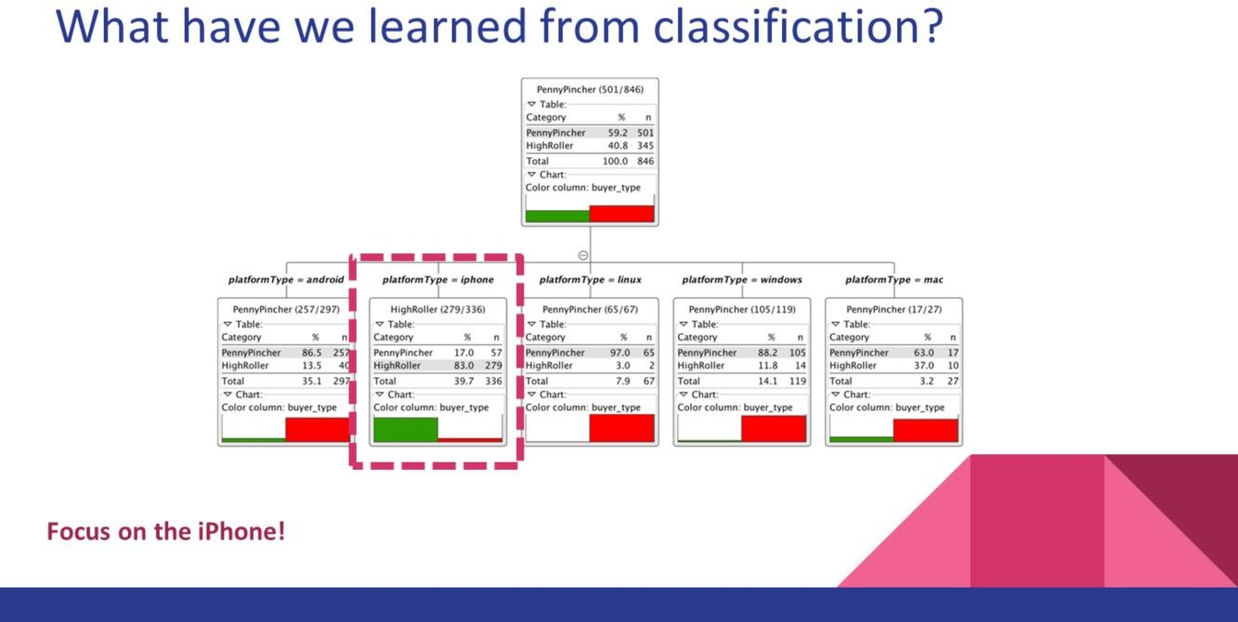

Most players are on mobile platforms, Iphone player are likely to be HighRoller while

android players tend to be PennyPinchers.

Promoting game among iOS and Mac users will increase the revenue.

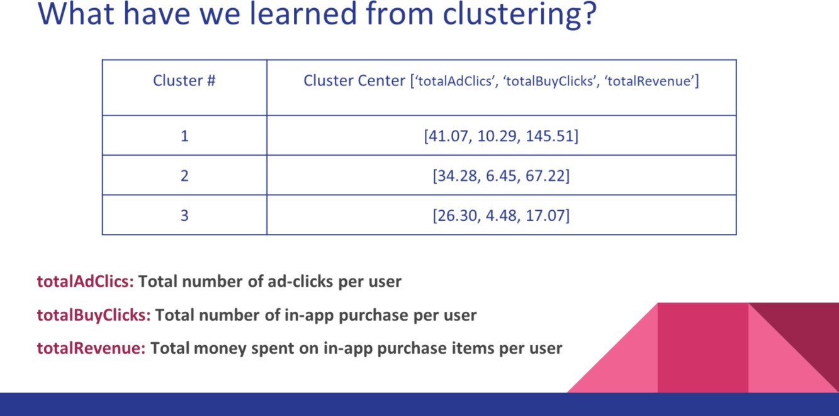

K-means Cluster analysis based on these 3 attributes resulted in 3 cluster

:

Cluster 1 is different from the others in that the players in the cluster have the highest ‘totalAdClics’, ‘totalBuyClicks’ and ‘totalRevenue’. They are frequent ad-clickers. We could increase the price for ads targeting for these players.

Cluster 2 is different from the others in that the players in the cluster have the second highest ‘totalAdClics’, ‘totalBuyClicks’ and ‘totalRevenue’.

Cluster 3 is different from the others in that the players in the cluster have the lowest ‘totalAdClics’, ‘totalBuyClicks’ and ‘totalRevenue’. They spend items with lower price. We could encourage them to spend more with promotional codes.

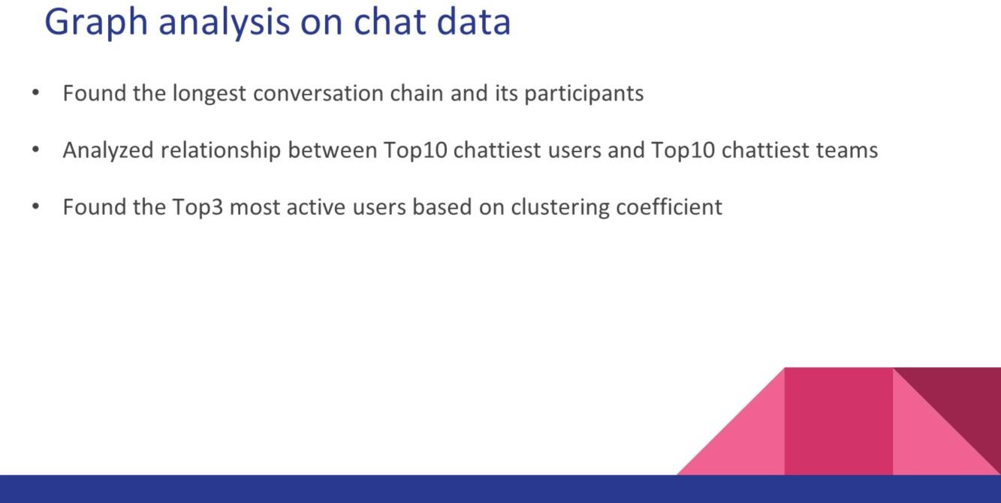

Found the longest conversation chain and its participants

We could use this information to find hottest topic and business strategies on those.

Analyzed relationship between Top10 chattiest users and Top10 chattiest teams

It seems that there isn’t relationship between chattiest users and chattiest teams. This suggests that we may need different business strategies between the two categories.

Found the Top3 most active users based on clustering coefficient

Promoting targeting these players should be more effective than “normal” players

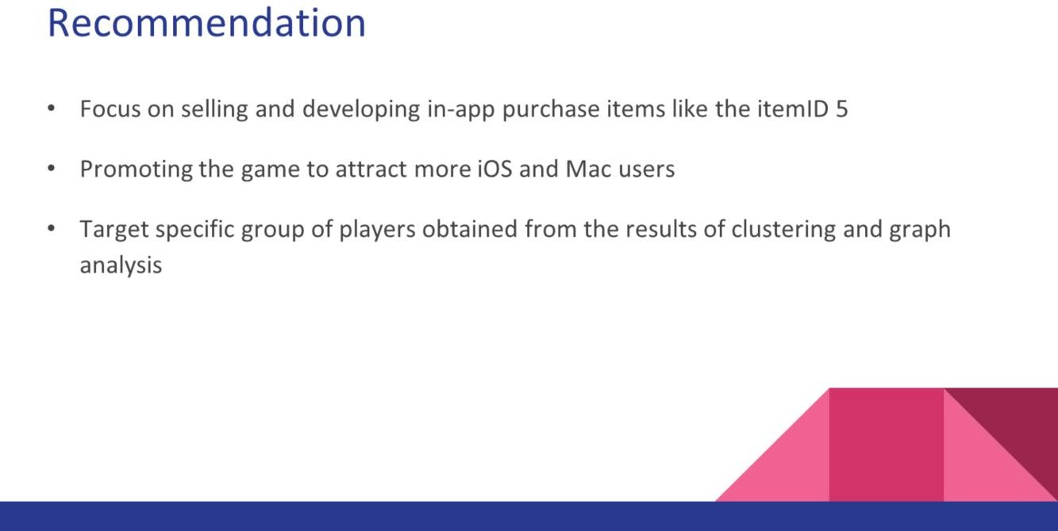

Focus on selling and developing in-app purchase items like the itemID 5, it’s the most

profitable item.

Promoting the game to attract more iOS and Mac users. Players on these two platform are more likely to be High Roller who are willing to spend more

Pushing promotion to the most influencer players, they could easily attract the community

End of Presentation

Thanks to all participants!